EXPERIMENT 1.3
IDENTIFICATION AND ANALYSIS OF OVER-MODULATION IN AM
1. AIM
To identify and analyze the over-modulation condition of an amplitude-modulated (AM) signal by calculating the modulation index and verifying that m is greater than 1 using MATLAB.
2. APPARATUS / SOFTWARE REQUIRED
- Computer or laptop
- MATLAB software
- MATLAB Editor
3. THEORY AND FORMULA
In amplitude modulation, the amplitude of a high-frequency carrier changes according to the modulating signal. The modulation index indicates the extent of carrier amplitude variation.
m = Am / Ac
Here, Am is the peak amplitude of the modulating signal and Ac is the peak amplitude of the carrier. Over-modulation occurs when m > 1. At m = 1, the signal is 100% modulated; when m < 1, under-modulation occurs.
Given: Am = 3, Ac = 2
m = 3 / 2 = 1.5 = 150%
Since 1.5 is greater than 1, the AM signal is over-modulated. The envelope crosses zero and becomes inverted during part of each modulating cycle, causing distortion and making simple envelope detection unsuitable.
4. MATLAB CODE
grid on;
legend('AM Signal','Envelope','Negative Envelope');
xlabel('Time (s)'); ylabel('Amplitude');
title('AM Signal - Over-Modulation (m > 1)');
plot(t, -envelope, 'r--', 'LineWidth', 1.4);
plot(t, envelope, 'r--', 'LineWidth', 1.4);
hold on;
plot(t, am_signal, 'b', 'LineWidth', 1.0);
subplot(3,1,3);

xlabel('Time (s)'); ylabel('Amplitude'); grid on;
title('Carrier Signal');
plot(t, carrier, 'k', 'LineWidth', 1.0);
subplot(3,1,2);

xlabel('Time (s)'); ylabel('Amplitude'); grid on;
title('Modulating Signal');
plot(t, message, 'b', 'LineWidth', 1.2);
subplot(3,1,1);

figure('Color','w');
% Plot signals

envelope = Ac*(1 + m*cos(2*pi*fm*t));
% Calculate envelope

am_signal = Ac*(1 + m*cos(2*pi*fm*t)) .* cos(2*pi*fc*t);
carrier = Ac*cos(2*pi*fc*t);
message = Am*cos(2*pi*fm*t);
% Generate signals

t = 0:1/fs:2/fm;
% Time vector

end
disp('Condition: Under-modulation');
else
disp('Condition: 100 percent modulation');
elseif m == 1
disp('Condition: Over-modulation');
if m > 1
% Check modulation condition

fprintf('Modulation Percentage = %.2f%%\n', m*100);
fprintf('Modulation Index = %.2f\n', m);
m = Am / Ac;
% Calculate modulation index

fs = 10000; % Sampling frequency in Hz
fm = 5; % Modulating frequency in Hz
fc = 100; % Carrier frequency in Hz
Am = 3; % Modulating signal amplitude
Ac = 2; % Carrier amplitude
% Signal parameters

close all;
clear;
clc;
5. MATLAB OUTPUT
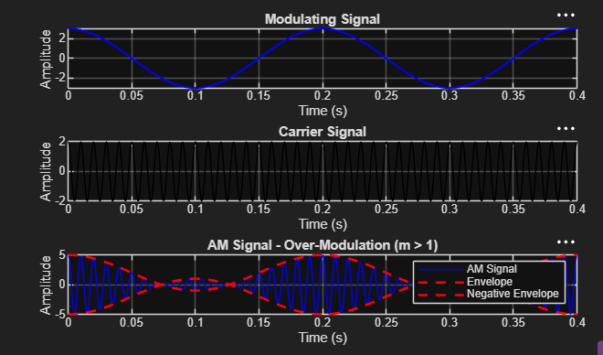
The output shows the modulating signal, carrier signal, and over-modulated AM waveform. Since the modulation index is greater than 1, the envelope crosses zero and the waveform is distorted.

6. RESULT
The modulation index was calculated as m = Am/Ac = 3/2 = 1.5 (150%). Since m > 1, the signal satisfies the over-modulation condition. The modulating signal, carrier signal, and distorted AM waveform with its envelope were plotted successfully in MATLAB.

